Contents

Introduction 1

Method 1

Data Analysis……………………………………………………………………………………………………………………………….3

1. All Crime …………………………………………………………………………………………………………………..........3

2. Homelessness …………………………………………………………………………………………………………..........4

3. Homelessness Related Crimes …………………………………………………………………………………..........6

Conclusion…………………………………………………………………………………………………………………………………………..9

Rachael Cole

November 2016

How can UK Police resources be better placed?

*Investigating the relationship between crime and homelessness in the UK*

Using police data for all regions of England and Wales over the period of one year and comparing it against data on homeless people to analyse if there is a correlation.

## Introduction

***Did you know?***

* *There were 200,922 workers employed by the 43 police forces in England and Wales on 31 March 2016, a decrease of 6,807 or 3.3% compared with a year earlier. [1]*
* *There were 6.3 million crime incidents reported by the end of the CSEW* survey year ending 31 March 2016. [2]*
* *The police recorded 4.5 million offences in the year ending March 2016. [2]*

*\*Crime Survey for England and Wales*

Every year, the UK police force deal with several million cases up and down the UK. They range from small crimes such as anti-social behaviour to larger crimes such as robbery. The brief of this project was to assist the Home Office to identify potential trends of crime throughout the UK to justify government spending and to try and prevent crimes threatening precious resources. The data would have to be cleansed and normalised before it could be analysed.

In this project, all crimes that took place in England and Wales between October 2015 and September 2016 were analysed. Homelessness data was then analysed to draw some conclusions between crime and homelessness and to see if they have any connections.

## Method



Figure 1 Entity Diagram

The first step in this project was to resource the police data from [data.police.uk/data/](https://data.police.uk/data/) and the population data from [www.ons.gov.uk](http://www.ons.gov.uk). This data contained all crime throughout England and Wales over the last five years. For the project, data from all regions was used but only from the most recent year. This was from October 2015 to September 2016. Microsoft Visual Studio was used to load all the data into SQL Server. The data was loaded from the original CSV file and imported via an OLE DB Destination editor.



Figure 2 Code for creating the normalised Crime Type table

Once the data had landed into a table in SQL Server, it had to be profiled, cleansed and normalised. This was because the entire table consisted of approximately 6 million rows and therefore was not easy to navigate or analyse. After profiling the data, the crimes dealt with by the British Transport Police were chosen to be ignored. This was because none of these crimes had any IDs assigned to them and there was also no data for the outcome column so overall there was a lot of missing data. Hence, it was concluded that these offences were not worth including as they were likely to be crimes caused on public transport and at or around stations. Consequently, the people committing these crimes were likely to not be representative of the population data for that area. This was because the chance was high that these crimes would be committed by commuters/ travellers who were not local to the area and so when the crime per person was calculated for each area, the population data would likely not cover the person who committed the crime. This could have risked the data being skewed and some places supposedly having higher crime rates when the crime was not actually committed in that area.

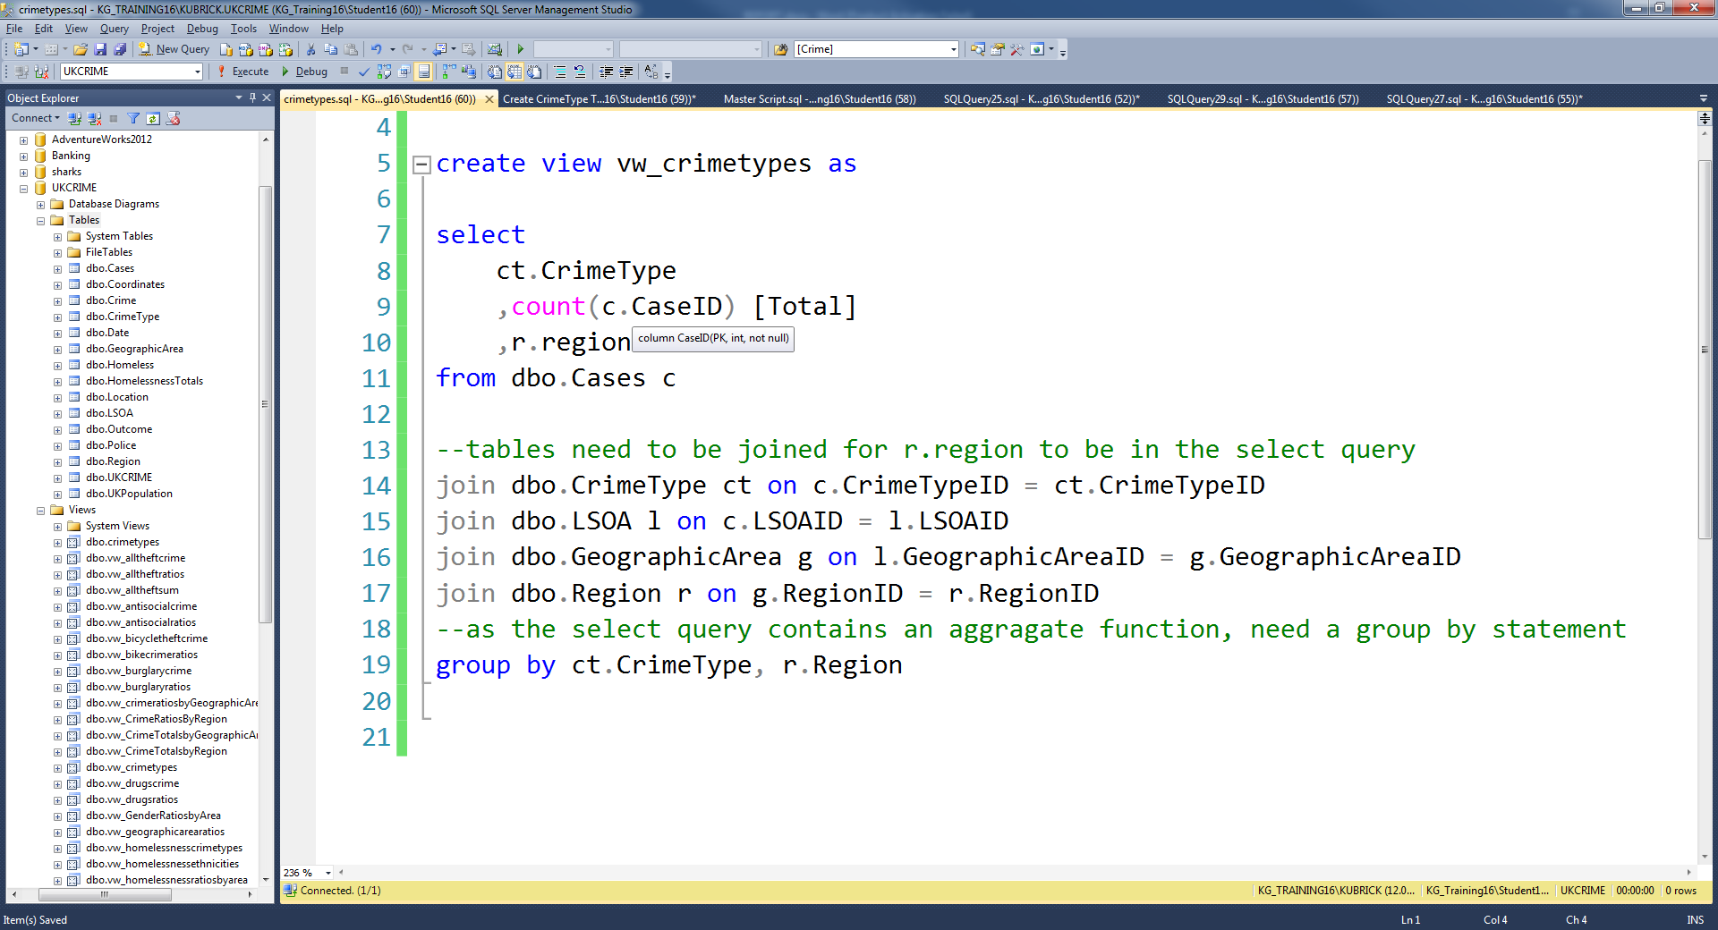

Figure 3 Code for creating a view to list the number of crime types in each region

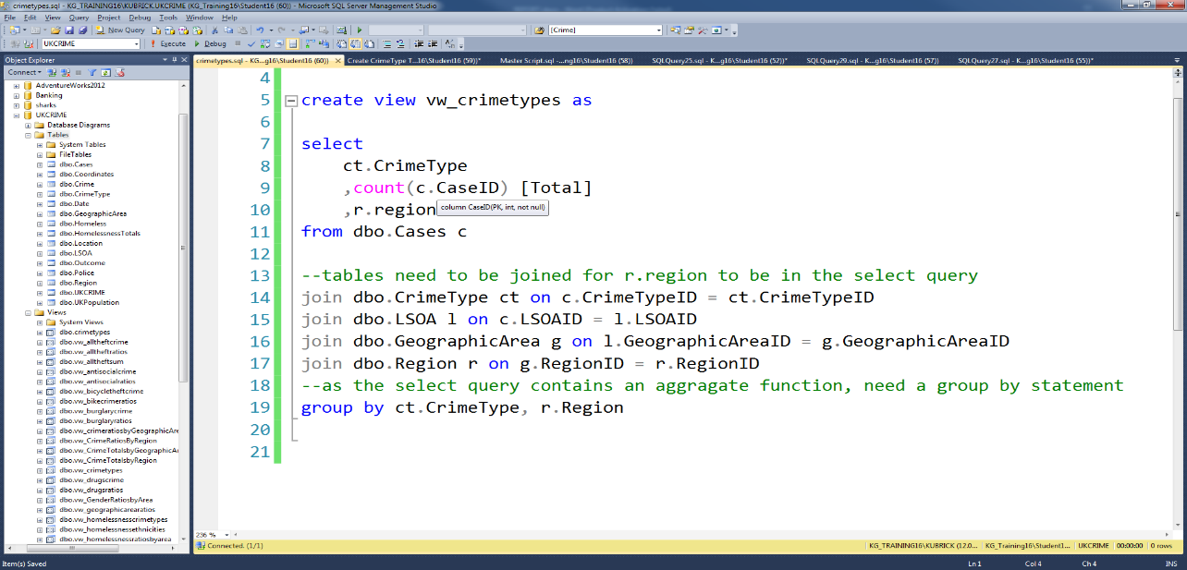

The normalisation process consisted of splitting up the table by columns and creating entities based on these columns. These entities were then joined back to a main table through primary and foreign keys. This meant that all data from the original table was stored in these new entity tables and the main table contained only primary keys. This way all data could be accessed in a much more efficient way so that when querying the data, it would take no time at all, unlike when querying the raw table which took several minutes. Figure 1 shows the entity diagram for all the data tables and how they all connect to each other through the primary keys. Within each entity are the original columns but in their corresponding table. Figure 2 shows the code for creating the Crime Type entity table. All other tables followed the same structure.

Before any analysing could take place, views of the data were created to pick out specific features of the data and so that graphs could be created easily from them. Figure 3 shows the code of one of the views created. Finally, charts were created using Power BI, Tableau, and Excel.

## Data Analysis

1. 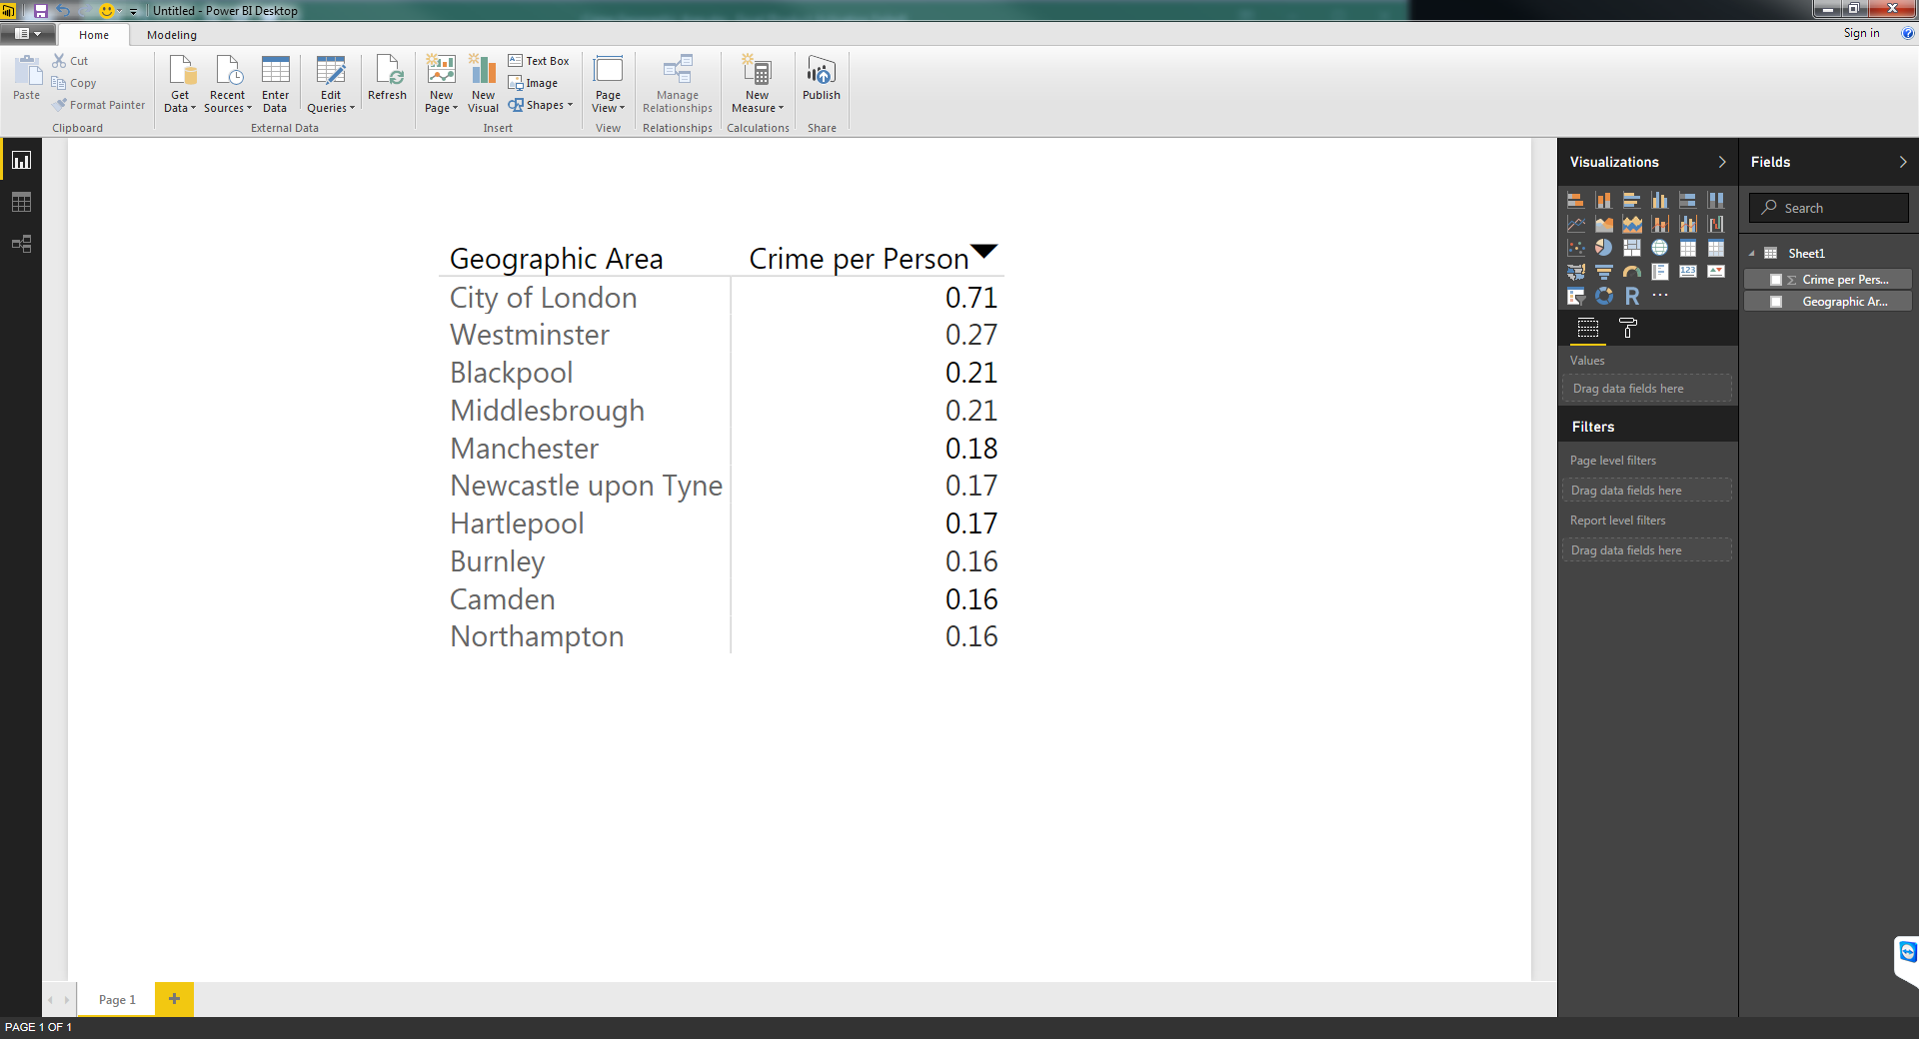All crime

Figure 5 Table showing the top 10 areas for crime per person

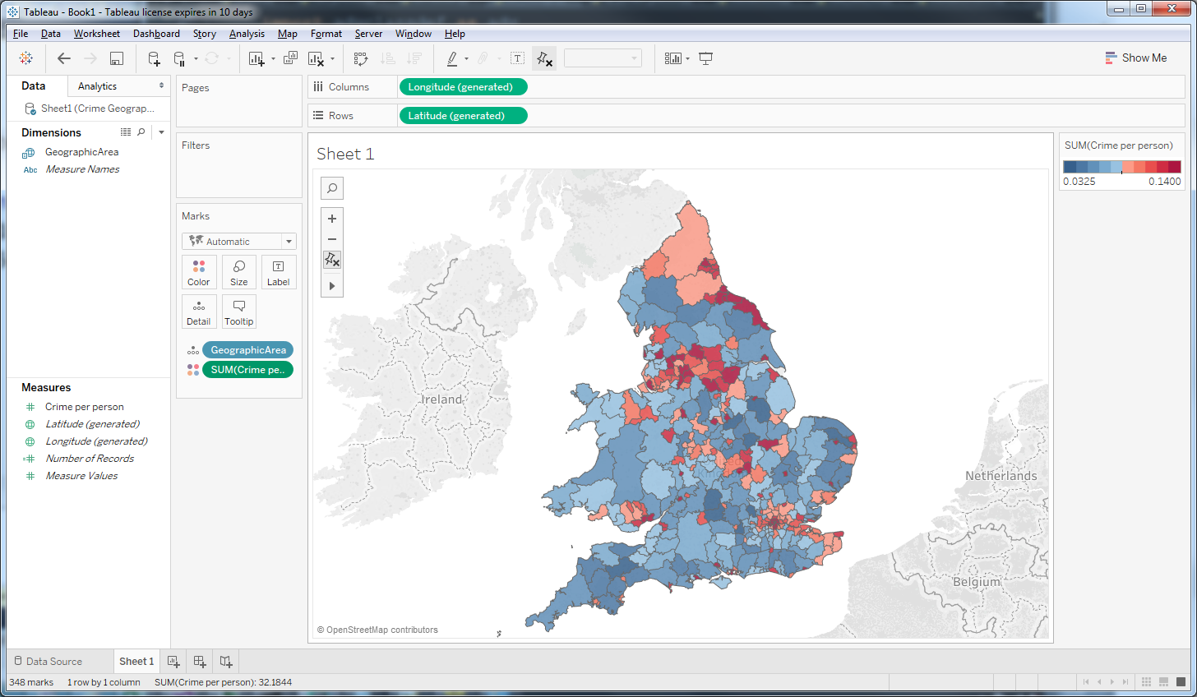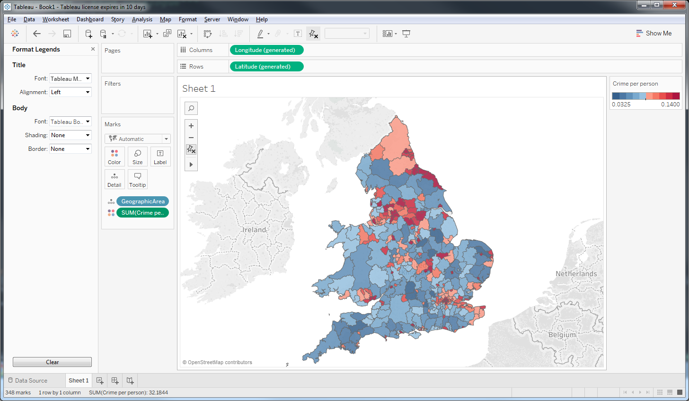

Figure 4 Heap map showing the crime per person across England and Wales





Figure 6 Pie Chart showing the fractions of types of crime that happen throughout the UK

Figure 7 Chart showing crime per person by region

As this project is looking at crime throughout the entire country, it is best to first look at where crime is distributed throughout the country. This is represented in the map in figure 4. The map is showing the total number of crime cases in an area divided by the total population in that area to get the number of crime cases per person. From figure 4, it is shown that the areas with the highest numbers of crime per person (ie, the dark red areas) are the major cities and their surrounding areas. For example, London, Manchester, and Newcastle are some of the areas with the darkest patches of red. Figure 5 shows the exact figures for the top ten areas for crime per person. The top area is the City of London with a comparatively very high rate of crime per person (0.71). This is because few people live there but a lot of people work and pass through it every day so there is a higher chance for crime. However, when looking at this data over a more general area – over regions rather than counties, the region with the highest amount of crime per person overall is the North-East with a total of 0.126 crimes per person (figure 7). Yorkshire and the Humber is second with London at fourth place. This is slightly different to the crime per person by geographic area as the population density is different between the two.



Figure 8 Pie Charts showing the fractions of crime types in the North East, the West Midlands and the South West

All crimes are categorised into different crime types. All crime types in order of the number of cases is shown in figure 6. The type with the most number of cases in the last year is anti-social behaviour with 31.22%. To see if this similar between individual regions and not just overall, figure 8 shows the crime types for the North-East, the West Midlands and the South West. Ie, taking the regions that had the highest, middle, and lowest crimes per person (Figure 7). By looking at the pie charts, anti-social behaviour is the highest crime type in all 3 regions so can be assumed that this is the biggest problem and takes up most of police time. Generally, they all follow the same trends with most crime types following the same order. Therefore, it can be assumed that figure 6 is mostly representative for all regions.

1. Homelessness

The other dataset that was used was one where homelessness is measured across England. This was used to determine whether there is a correlation between crime and homelessness. The term ‘homelessness’ has a broad definition in that it includes statutory homelessness, single and hidden homelessness as well as rough sleeping. In this project only sleeping on the streets has been investigated. Figure 9 shows the rates of homelessness for every person living in that area, across the country. Although the numbers are very low overall, it can be seen that the main cities including London and Manchester, have the highest levels of people sleeping on the streets.

**Homelessness Facts**

* *Homelessness is measured differently across the UK, making it difficult to obtain an official figure. [3]*
* *The meaning consists of more than just sleeping on the streets – also includes statutory homelessness (homelessness applications made to the local authorities), single and hidden homelessness (those who end up surviving out of sight e.g. staying in a hostel or squatting on the floors or sofas of friends and family). [3]*
* *The main cause of homelessness is relationship breakdown but there are often many other factors that come into play. [4]*
* *Being homeless can increase the chance of taking drugs or experiencing physical or mental health problems. [4]*
* *As a situation gets more complex, anti-social behaviour, involvement with crime and acute NHS services become more likely. [4]*

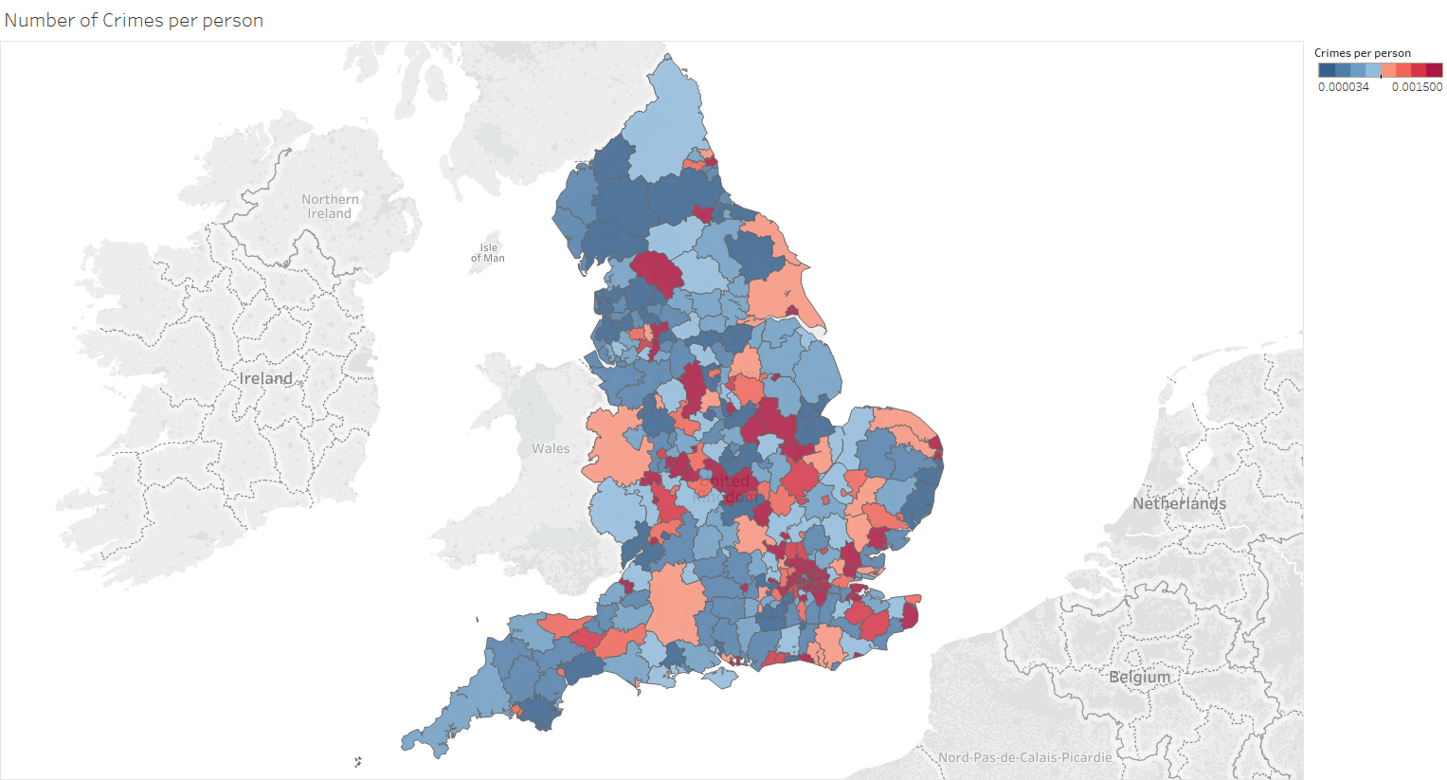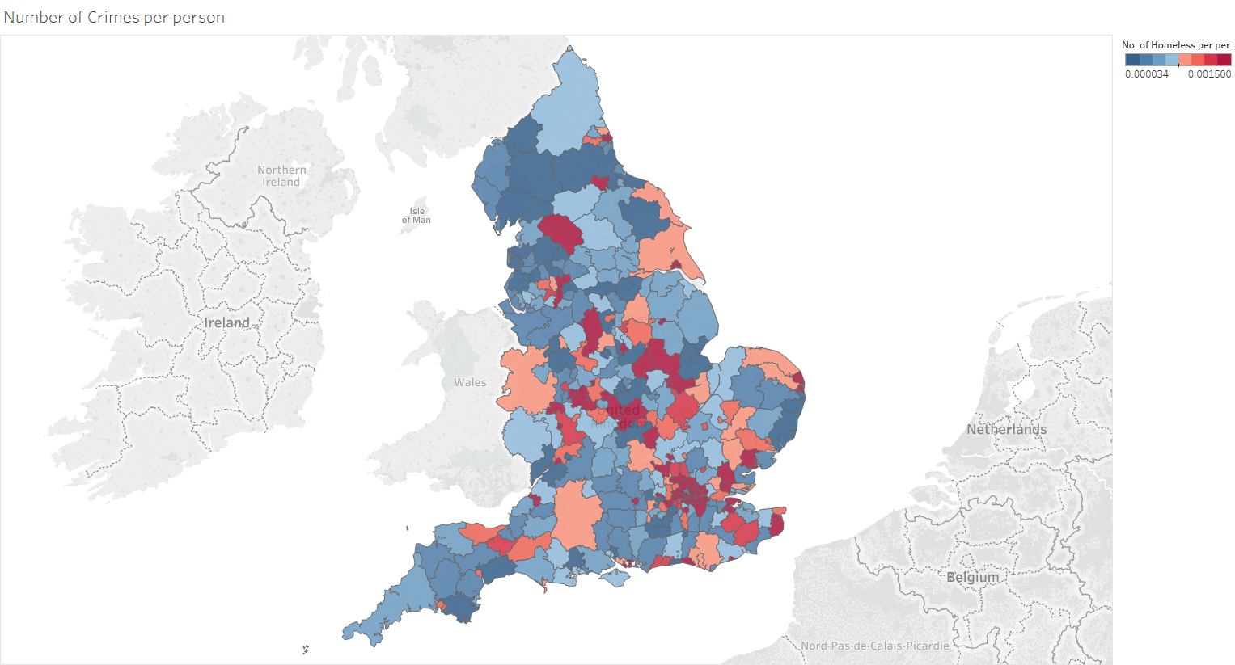

Figure 9 Heat map showing the levels of homelessness (per person) within England and Wales

The homelessness dataset is broken down into ethnicities. This data is represented in figure 10. Apart from London, all regions have the majority of homeless people being of a white ethnicity. For example, the North East has 91.23% of homeless people being white. As London is a lot more culturally diverse – especially in comparison with the rest of the country, there are more equal percentages between those with a white (33.31%) or black (32.02%) ethnicity. The black ethnicity comes second for most regions.

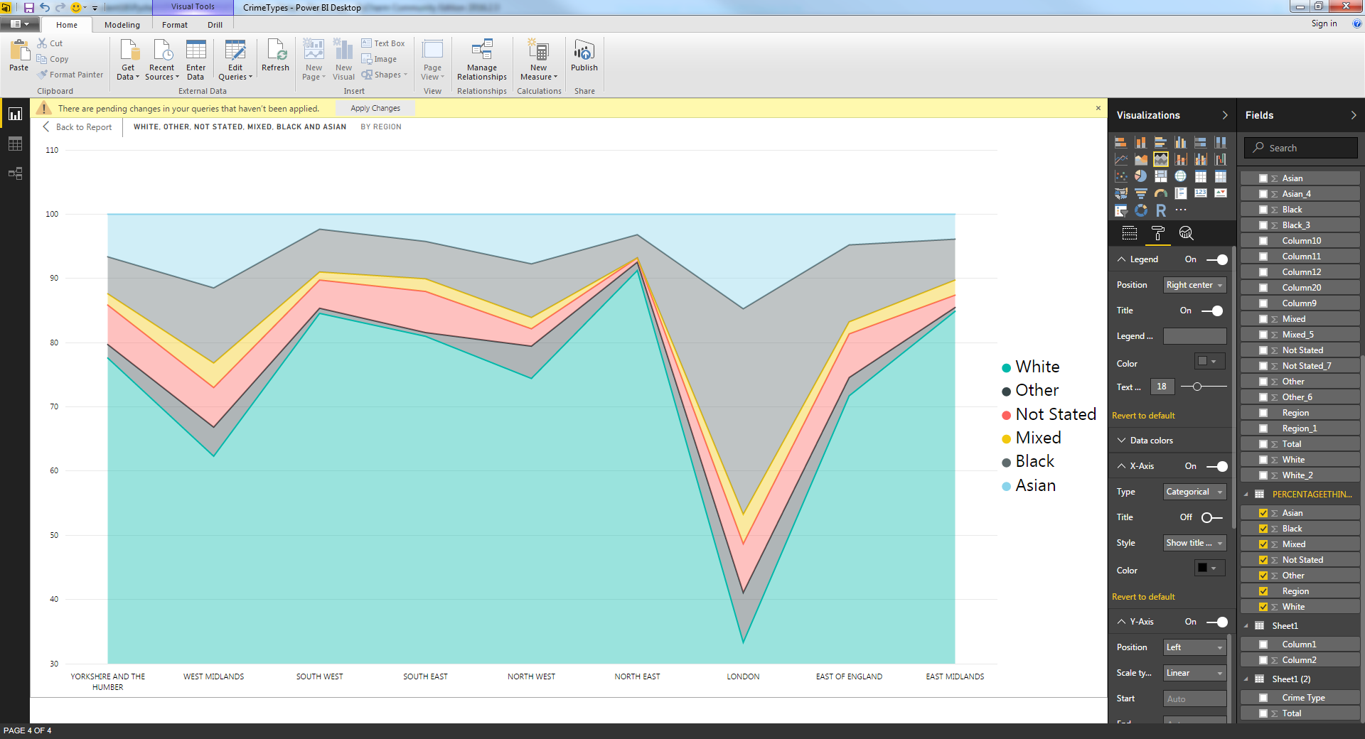

Figure 10 Chart showing the percentage of homeless people’s ethnicities by regions

1. homelessness related crime

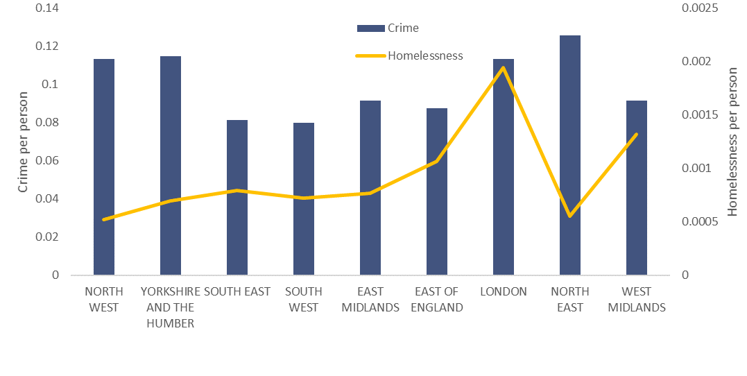

Figure 11 Bar chart of crime per person plotted with line graph of homelessness per person

Figure 11 shows the result of crime per person plotted on a bar chart with homelessness per person plotted on a line graph on top of it. There is not an obvious trend between the two datasets. It could be suggested that in London they may be slightly connected but the same cannot be said for the North-East. However, if the crimes relating to homelessness are used rather than grouping all crime together, there may be a better outcome. The crimes that somebody who is homeless may commit are theft (bicycle theft, theft from the person and other theft), anti-social behaviour, drugs related crime, shoplifting and violence & sexual crime. Hence, these have all been analysed individually.

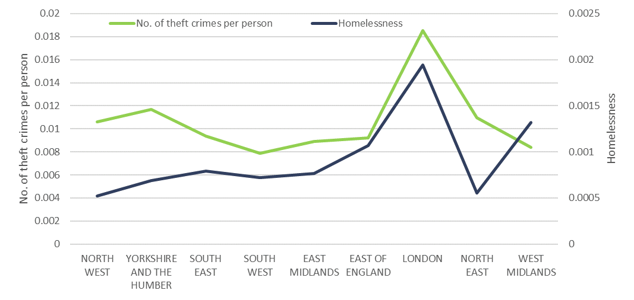

Figure 12 Line graphs showing homelessness vs. number of theft crimes per person

Figure 13 Line graphs showing homelessness vs. number of anti-social behaviour crimes per person

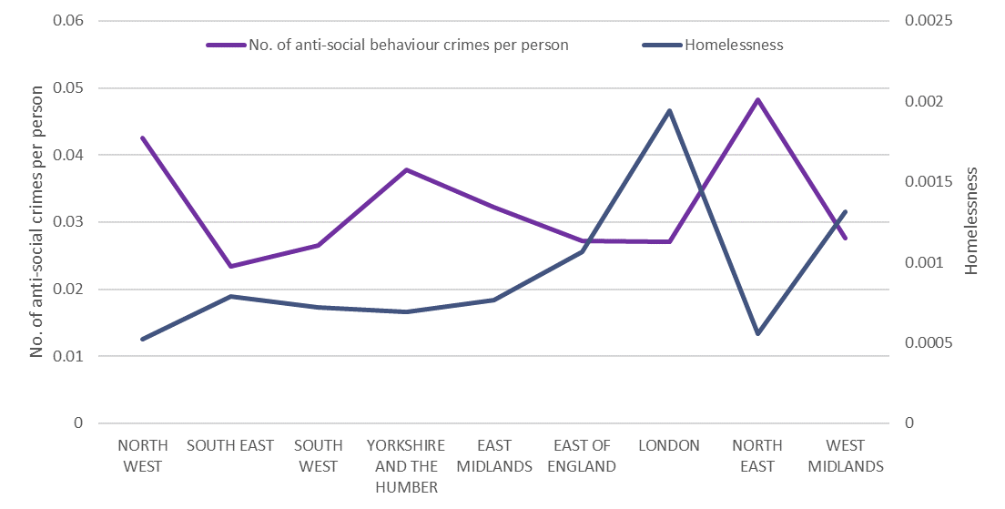

Figure 14 Line graphs of homelessness vs number of drug related crimes per person

*“Drug related crimes have a correlation with homelessness but shoplifting has no obvious trend”*

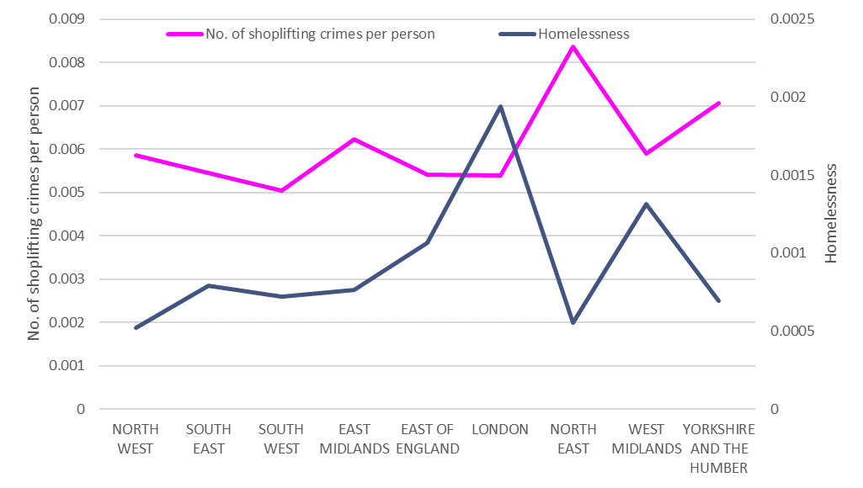

Figure 15 Line graphs of homelessness vs. number of shoplifting crimes per person

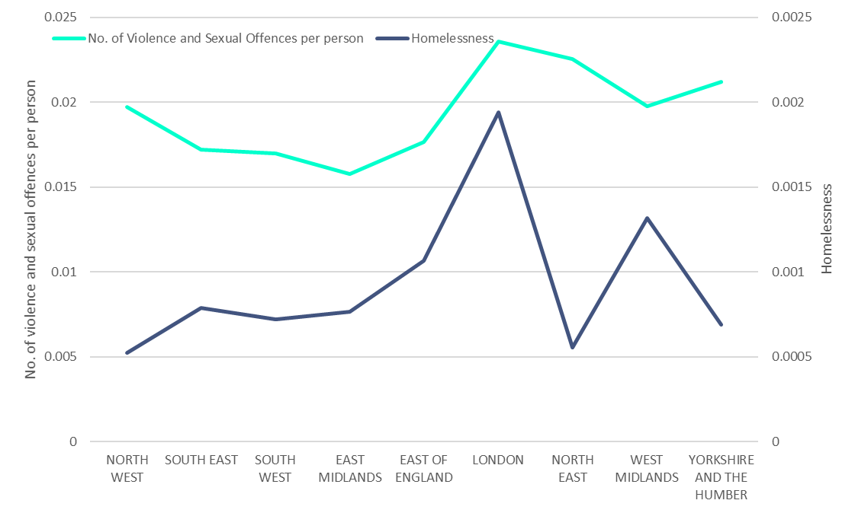

Figure 16 Line graphs of homelessness vs. number of violence and sexual offences per person

Figures 12-16 show homelessness against individual crime types. From analysing all five graphs, it can be deduced that theft has the closest trend with homelessness. As shown in figure 12, they both follow a similar pattern as they both peak in London and for the most part, they increase or decrease for the same regions. Drug related crimes also have a correlation with homelessness (figure 14). They peak in London and for the majority of regions, increase and decrease at similar times. Only in the North West do the lines not move together.

However, shoplifting and violence & sexual crimes have no obvious trend with homelessness (figures 15 and 16). Their peaks and troughs are in completely different regions and the lines of each set of data do not appear to follow a pattern. After looking at all five graphs, it can be understood that only theft and drug related crimes may have an influence on crime committed by a homeless person.

## Conclusion

In conclusion, the region with the highest values for crime per person is the North East of England. However, when looking at geographic areas, the city of London and Westminster have the highest number of crimes committed per person. The reason these numbers are much higher is that these areas have a much smaller population compared to the rest of London and other areas due to them being mostly non-residential areas and there are also more crimes committed overall. The North East is the same but on a bigger scale. Hence, there are these differences in results when comparing between region and geographic area. When looking at different types of crime, anti-social behaviour is the biggest problem within the UK. However, despite initially assuming that anti-social behaviour and homelessness would have a trend, the data suggests differently and compared to other crime types, homelessness doesn’t have a significant impact on the number of anti-social behaviour crimes.

If the Home Office wanted to move their police resources in order to target crime better, the best suggestion would be

To take this project further, data for ethnicities within the entire population and also for crime could have been found to make comparisons with the homelessness ethnicity data.

## Bibliography

[1]<https://www.gov.uk/government/uploads/system/uploads/attachment_data/file/544849/hosb0516-police-workforce.pdf>

[2]<https://www.ons.gov.uk/peoplepopulationandcommunity/crimeandjustice/bulletins/crimeinenglandandwales/yearendingmar2016>

[3] <http://www.crisis.org.uk/pages/homeless-def-numbers.html>

[4] [http://www.homeless.org.uk/facts/understanding-homelessness/](http://www.homeless.org.uk/facts/understanding-homelessness/causes-of-homelessness)